DOES BEING SEXUALLY ACTIVE IMPACT/EQUATE TO HAPPINESS (ESPECIALLY HERE AT RUTGERS)



INTRODUCTION

I was not sure of what to do when I saw this assignment at first, so I decided to look for inspiration. I stumbled upon the Happiness at Rutgers Article that was listed on the Data Science Blog and it inspired me. At first I wanted my data to be from Rutgers students alone, but I decided to include more people and get their opinions. This might be a controlled dataset in a way. Before coming to Rutgers, I didn’t really know anything about this school, so I tried doing some research, and I stumbled upon a website talking about how Rutgers had one of the highest rates of STDs compared to other universities and I wondered why that was. This was why I decided on my topic, does being sexually active equate to or impact happiness? After a while, I opened it up to non-Rutgers students too, although I made a subset of Rutgers students that I would also work with. I created the Google form, and I got about 98 responses. It was a funny one as a lot of people found it hilarious, I feel like this might have been a controlled experiment in a way , as I am, an SAS student so more SAS students filled this form than other schools, and there are also other factors that affect this that I will mention in the conclusion.

QUESTIONS

Like I mentioned earlier, I created a Google form, and linked a Google spreadsheet to this form. These were the questions I asked, and the pie chart/ bar graph of their answers.

NOTE: Keep in mind a percentage of non-Rutgers students filled this form too (31.6%)

YEAR WITH KNOWLEDGE ON SEX EQUATING TO/IMPACTING HAPPINESS

I did a mosaic graph on students (both Rutgers and Non-Rutgers), and their stance on sexual activeness equating happiness. To calculate the Z-test though, I had to go back to excel and work out a formula that equates ‘Yes’, and ‘Maybe’ to 1s, and ‘No’s to 0s . I made Maybes 1s under the assumption that uncertainty/silence on this matter might be taken as acknowledgement.

Z-TEST

I did a z-test using the whole dataset after seeing the mosaic graph, like I said earlier, I equated Yesses and Maybes to 1s and Nos to 0s. Before doing this I did a tapply test for the means.



This was when I realized that a larger group of youths believe that sexual activity might impact happiness. I also noticed this when I realized that ‘Maybe’ had a relatively high percentage. It seemed to be that there were hidden variables stopping them from picking ‘Yes’, but adding maybes and yesses together, it was higher than the Nos. I decided to try setting different null hypotheses about the year.

NULL HYPOTHESES

* Sophomores and Freshmen both equate sex to happiness (equally), this null hypothesis fails to be rejected, as its p-value is 0.09870912.

* Juniors and Sophomores both equate sex to happiness (equally), this null hypothesis fails to be rejected as its p-value is 0.09693433.

* Seniors and Juniors both equate sex to happiness (equally), this null hypothesis fails to be rejected as its p-values is 0.08353214.

I didn’t work with Graduate School for this as I wanted to use undergraduates for this discovery. I decided to do a Z-test using the highest mean and lowest means of undergraduate school years to test its randomness. The null hypothesis for this was:

* The no. of Junior students who believe sex equates to happiness is the same as the no. of Freshmen. This hypothesis is rejected as the p-value is 0.001085937.

I believe one’s year might influence their stance on this issue, as age/maturity might be a hidden variable that leads to the difference in opinions.

SCHOOL AND ITS EFFECTS

I decided to test schools and how it relates to people’s stance on sexual activeness equating happiness. Like I did earlier, I equated Yesses and Maybe to 1s, and Nos to 0. I wanted to see how schools affected it, surprisingly most people outside Rutgers were against the opinion that sexual activeness equaled happiness.

This mosaic graph shows the opinion of students by their school.

This mosaic graph shows the opinion of Rutgers students by their school.

Z-TEST

I did a test using the whole dataset after seeing the mosaic graph, like I said earlier, I equated Yesses and Maybes to 1s and Nos to 0s. Before doing this, I did a tapply test for the means.

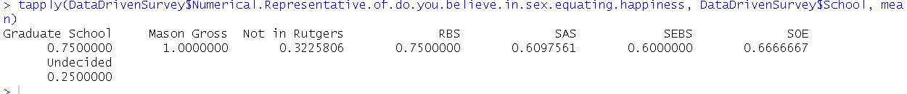

I tried some z tests, by forming some null hypothesis using schools like I did with Year, but all failed to be rejected, I couldn’t use Mason Gross, as Z-test was able to filter out that the sample size for Mason Gross wasn’t good enough for performing Z-test, but the other failed to reject the null hypothesis.



These are some of the graphs.

SEXUAL ACTIVENESS AND ITS EFFECTS

I will now be using sexual activeness with their response to gauge this opinion.

First, I will make a boxplot of the Category Sexual Activeness, and how it affects happiness on a scale of one to 10.

This shows that being sexually active affects the happiness of sexually active people more than people that are not sexually active. I also tried getting the boxplot of different subsets like

Rutgers Students

Rutgers Undergraduate Students

Undergraduate Students

There’s a hidden variable of STDs, and this is a table showing their responses,

Z-TEST

I decided to form a null hypothesis with sexual activeness category.

* Both Sexually active and Non-Sexually active people believe that sexual activeness will make them happy. The p value was 0.0001085697. This means that we can reject the null hypothesis, as 0.0001<0.05 (0.05 can be said to be the significance value), meaning that more sexually active people believe sex would make them happy than non-sexually active people.

* I tried this hypothesis with the Rutgers subset and I got a p value of 0.01326125, this also means we can reject the null hypothesis.

I also made mosaic graphs for this.

I made one for the Rutgers Subset too.

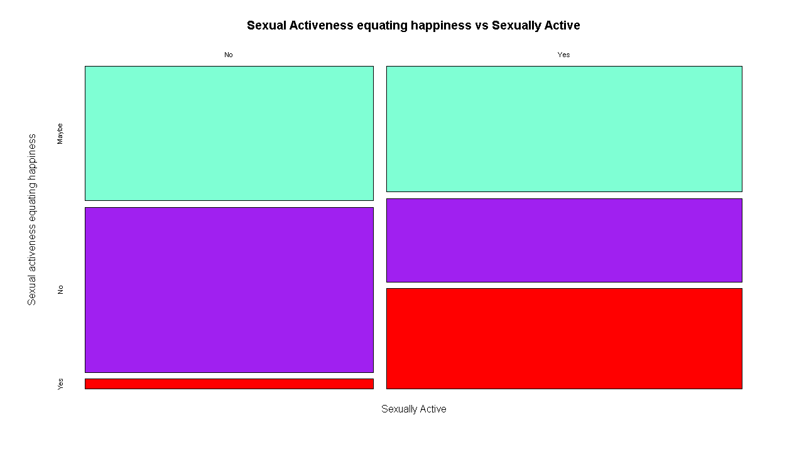

I finally decided to subset the Sexual Activeness to form more hypotheses, but all the null hypotheses failed to be rejected, so I suspect randomness.

I decided to subset Rutgers undergraduate students, to work on this subset, and I used a tapply function to find its mean.



* Both sexually active people and non-sexually active believe sex would make them happy, we can reject this null hypothesis as the p-value is 0.0144639.

CONCLUSION

Before doing this, because of the article I had seen on how sexually active Rutgers is, I had believed that most people would believe that sexually activeness would affect their happiness positively. After conducting this minor research, I believe my alternative hypothesis would be Sexually active people believe sex would make them happy more than non-sexually active people, The same goes for the dataset that includes non-Rutgers students. Although, something to be noted is that in my dataset, there were more sexually active Rutgers students than non-sexually active. They are hidden variables that affect this too, and one might be age/maturity as the mosaic graphs might suggest when we look at the academic years of the people who filled the form. Some of this data might be biased in the case that people might not want to answer truthfully, and aside from that the students not from Rutgers were not limited to U.S. alone but other countries too. Aside from this, there are other hidden variables that I did not mention, some of which might include factors affecting happiness in general like one’s sleep schedule.

BONUS: I used another Excel Formula to group the data into Rutgers and Non-Rutgers, and I made another mosaic graph.

